The Guadalupe Experience
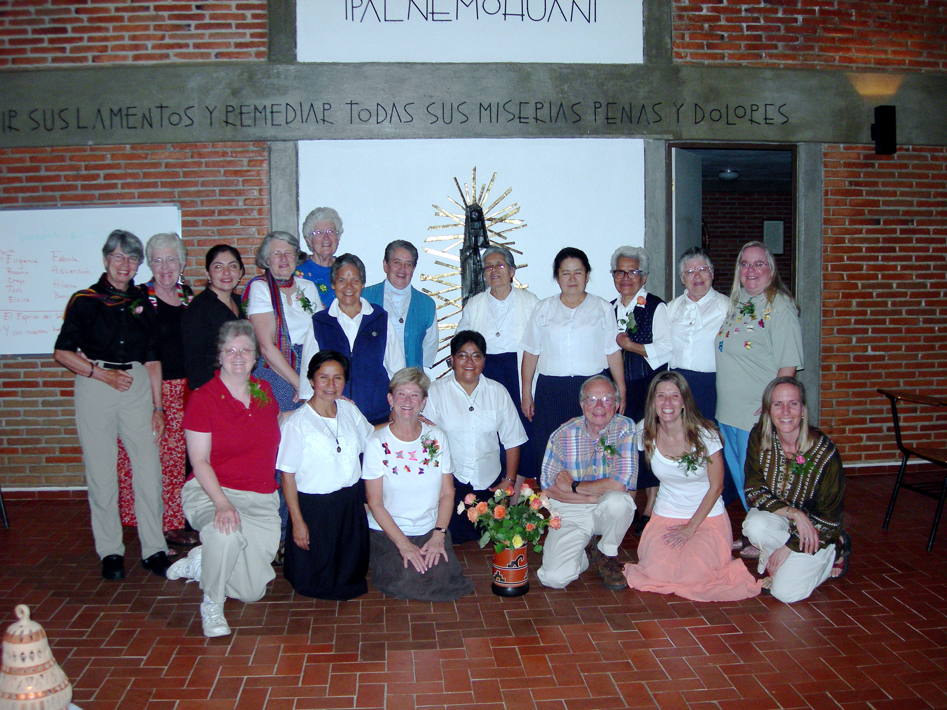
Come meet the people and experience the
culture and faith of Mexico

October 9-18, 2007

This experience is a retreat, a study tour, a pilgrimage…
- Learn the story and theology of Our Lady of Guadalupe from the sisters themselves at the Mexico City motherhouse
- Spend a day at the Basilica and the site of the appearance of La Virgin de Guadalupe
- During your week in Cuernavaca at the retreat center of the Sisters, you will have a private room with bath. All meals are prepared and served by the sisters, who provide our transportation and serve as our guides.
- Visit the Cathedral of Cuernavaca,
- See Cortez’ Palace, the museum of history and the murals of Diego Rivera
- Climb a pyramid and hear its history
- Spend an evening with a Christian base community
- Visit with the sisters in the homes of the poor
- Spend a day in an indigenous community
- Buy your souvenirs from co-ops and hear the stories of the artisans themselves
- Hear presentations about Mexican economics, history and politics
- Learn about Liberation Theology as you worship daily with the sisters

Cost: $700 + airfare (around $500)
(A $200 deposit must be received by April1st to guarantee a place on the tour)

The trip is sponsored by the Council of Churches of Santa Clara County. For more information and an application, contact Rev. Margo Tenold (408-297-2660) or revmargo@earthlink.net.

